# Personal E-Notes Management

A Mini Project Report submitted to Chaitanya Deemed to be University in partial fulfillment of minimum academic requirements for

## BACHELOR OF TECHNOLOGY

**COMPUTER SCIENCE AND ENGINEERING**

**Submitted By**

**UPENDAR THOTA (221202076)**

**CHANDU PODILA (221202079)**

**RAJINIKANTH MALLELA (221202083)**

**SAINIKHIL MARKA (221202109)**

**Under the guidance of**

**Mr.V.Srujan (Asst.Professor)**

**DEPARTMENT OF COMPUTER SCIENCE AND ENGINEERING**

# FACULTY OF ENGINEERING, CHAITANYA DEEMED TO BE UNIVERSITY

**HANAMKONDA, WARANGAL - 506001**

Accredited by NAAC “B++” Grade

(Affiliated to Chaitanya deemed to be university)

(2023-2024)

# FACULTY OF ENGINEERING

**HANAMKONDA, WARANGAL - 506001**

**DEPARTMENT OF COMPUTER SCIENCE AND ENGINEERING**



**CERTIFICATE**

This is to certify that the industrial Training report entitled “**Personal E-Notes Management”** is being submitted by **UPENDAR THOTA (2212202076), CHANDU PODILA (221202079), RAJINIKANTH MALLELA (221202083), SAINIKHIL MARKA (221202109),** in the partial fulfillment of the requirements for the award of the degree of **Bachelor of Technology** in “**Computer Science and Engineering**” at the **Chaitanya deemed to be University** during the academic year 2023-2024.

Signature of Project Guide Signature of HOD

(Mr.V.Srujan Asst.Professor) (Dr. E. Aravind assoc. Professor)

Signature of Dean

(Prof. G. SHANKARLINGAM)

**Signature of External examiner with Date**

# ACKNOWLEDGEMENT

The success accomplished in this project would not have been possible, by timely help and guidance rendered by many people, we wish to express our sincere and heartfelt gratitude to all those who have helped and guided us for the completion of the project.

We sincerely extend our thanks to **Mr.V.Srujan (Asst.Professor)**, Department of Computer Science and engineering for giving us moral support, kind attention and valuable guidance to us throughout this training work.

We extent our heartfelt thanks to **Dr. E. Aravind** of the Department of Computer Science and Engineering for his encouragement during the progress of this Industrial Training work.

We would like to express our deep sense of gratitude to **Prof. G. SHANKARLINGAM**, **Principal**, Faculty of engineering, for providing the required facilities in the college campus.

We would also thank all the staff of department of Computer Science and Engineering who has helped us directly or indirectly for the successful completion of the project.

Finally, we express our sincere thanks & gratitude to our family members & friends for their constant encouragement and moral support, which made the project successful.

**UPENDAR THOTA (221202076)**

**CHANDU PODILA (221202079)**

**RAJINIKANTH MALLELA (221202083)**

**SAINIKHIL MARKA (2221202109)**

# DECLARATION

We here submit that the mini project report entitled **“PERSONAL E-NOTES MANAGEMENT”** is an original work done at **Faculty of engineering, Hanamakonda** under the valuable guidance of **MR**.V.**SRUJAN (Asst.Professor), Department of Computer Science and Engineering,** in partial fulfillment of the requirement for the award of the degree of **Bachelor of Technology** in Computer Science and Engineering. We hereby declare that this project report bears no resemblance to any other reports submitted at *Faculty of Engineering* or any other college affiliated to Chaitanya deemed to be University for the award of the degree.

**UPENDAR THOTA (221202076)**

**CHANDU PODILA (221202079)**

**RAJINIKANTH MALLELA (221202083)**

**SAINIKHIL MARKA (221202109)**

**ABSTRACT:**

The Personal E-Notes Management project emerges as a timely and indispensable solution in the digital landscape, where the effective organization and management of personal information are paramount. In response to the evolving needs of individuals immersed in a world dominated by electronic data, this project sets out to revolutionize the note-taking experience. The primary objective is to create a dynamic web-based application that not only facilitates the creation and editing of electronic notes, termed E-Notes, but also provides users with an advanced set of features for seamless organization and retrieval. One of the cornerstones of the project is the development of a sophisticated text editor that empowers users to craft and refine E-Notes with unprecedented ease and versatility

Catering to the diverse needs of users, the project implements robust organizational tools, including categorization and tagging functionalities. These features not only contribute to efficient note organization but also ensure quick and intuitive retrieval, mitigating the challenge of sifting through a myriad of digital information. A pivotal aspect of the project is the focus on security. Recognizing the sensitivity of personal information, the application implements stringent user authentication protocols. This ensures the privacy and security of users' electronic notes, instilling confidence in the use of the platform for personal and professional documentation.

With a commitment to accessibility, the project places emphasis on responsive design. The user interface is meticulously crafted to provide an intuitive and seamless experience across various devices, acknowledging the dynamic nature of modern work and lifestyle. In essence, the Personal E-Notes Management project is poised to redefine the digital note-taking landscape. It aims to empower users with a comprehensive, secure, and user-friendly platform, enhancing personal organization, productivity, and the overall digital experience in an interconnected world.

**TABLE OF CONTENTS**

**CHAPTER- 1: INTRODUCTION……………………………………………...07**

**CHAPTER-2: SYSTEM STUDY……………………………………………08-09**

2.1 PROPOSED SYSTEM………………………………………………..08

2.2 EXISTING SYSTEM…………………………………………………09

**CHAPTER-3 SYSYTEM REQUIREMENTS……………………………..10-11**

3.1 SOFTWARE REQUIREMENTS…………………………………….10

3.2 HARDWARE REQUIREMENTS………………………………….10

3.3 FUNCTIONAL REQUIREMENTS………………………………..11

3.4 NON-FUNCTIONAL REQUIREMENTS…………………………11

**CHAPTER -4: SOFTWARE DESIGN……………………………………12-14**

3.1 ER-DIAGRAMS……………………………………………………12

3.2 CLASS DIAGRAMS……………………………………………….13

3.3 USE CASE DIAGRAMS…………………………………………..14

**CHAPTER -5: IMPLEMENTATION ……………………………………15-34**

5.1SAMPLE CODE………………………………………………...15-25

5.2OUTPUT SCREENS…………………………………………….26-34

**CHAPTER-6: CONCLUSION…………………………………………………35**

**CHAPTER -7: FUTURE SCOPE……………………………………………...36**

**CHAPTER-8: REFERENCES…………………………………………………37**

**CHAPTER-1**

**INTRODUCTION**

The Personal E-Notes Management project is conceived with the goal of providing individuals with a versatile and secure platform for managing electronic notes or E-Notes. In an era where digital information is prevalent, the need for a robust solution to organize, edit, and retrieve electronic notes has become increasingly vital. This project aims to fulfill that need by creating an intuitive and feature-rich application tailored to the preferences and requirements of users.

The project's scope involves the development of a webs-based application that empowers users to efficiently create, organize, and access their electronic notes. With features such as rich text editing, the application aspires to be a comprehensive solution for individuals seeking a digital note-taking platform. It is designed to cater to various user profiles, including students, professionals, and anyone desiring an effective and secure method for managing electronic notes.

Provide users with a feature-rich text editor for creating and editing electronic notes with ease. Implement strong user authentication and data encryption to ensure the privacy and security of users' electronic notes. Design an intuitive and responsive user interface to enhance accessibility across various devices. Implement robust categorization and tagging functionalities for efficient organization and retrieval of E-Notes.

**CHAPTER -2**

**SYSTEM STUDY**

**2.1 PROPOSED SYSTEM**

The proposed system for Personal E-Notes Management is a user-centric digital platform aimed at revolutionizing how individuals organize, access, and interact with their personal notes and information. With a focus on simplicity, efficiency, and customization, this system seeks to address the growing need for a comprehensive solution to personal note-taking and organization. At its core, the system offers a user-friendly interface designed to streamline the note-taking process. Users will have the ability to create, edit, and format notes in various formats text. Advanced formatting options will enable users to customize the appearance of their notes to suit their preferences and needs.

Organization is a key aspect of the proposed system. Users will benefit from a range of organizational tools, such as tags to classify and manage their notes effectively. This hierarchical structure will facilitate easy navigation and retrieval of information, saving users time and effort. Search functionality will be another cornerstone of the system, allowing users to quickly locate specific notes using keywords, dates, or other relevant criteria. Advanced search filters will further enhance the accuracy and efficiency of the search process, ensuring that users can find what they need with ease.

Security and privacy will be top priorities in the design of the system. Robust encryption protocols, secure authentication mechanisms, and access controls will protect users' personal information and sensitive data, ensuring peace of mind.

Overall, the proposed system for Personal E-Notes Management represents a comprehensive and user-centric solution to the challenges of personal note-taking and organization. By combining intuitive design, powerful features, and robust security, the system aims to empower users to take control of their digital lives and enhance their productivity and efficiency.

**2.2 EXISTING SYSTEM**

The existing landscape of Personal E-Notes Management Systems encompasses a variety of tools and platforms, each offering unique features and functionalities to cater to users' note-taking and organization needs. While there is a diverse range of options available, they generally fall into several categories, including note-taking apps, document management systems, and productivity platforms.

One prevalent category within the existing system is standalone note-taking applications like Ever note, OneNote, and Google Keep. These apps offer users the ability to create and organize digital notes in various formats, such as text, images, audio, and video. They often provide features like tagging, categorization, and search functionality to help users organize and retrieve their notes efficiently. However, these standalone apps may lack robust collaboration features and integrations with other productivity tools, limiting their utility for users who require seamless collaboration or integration with their existing workflows.

Another category within the existing system is document management systems such as Drop box , Microsoft One Drive , and Google Drive. These platforms offer users the ability to store, organize, and share documents, including notes and other types of files. While document management systems excel at file storage and sharing, they may lack advanced note-taking features and customization options found in dedicated note-taking apps.

Additionally, productivity platforms like Microsoft Office 365, Google Workspace, and Notion also play a significant role in the existing system of Personal E-Notes Management. These platforms offer a suite of productivity tools, including note-taking, document editing, task management, and collaboration features. While productivity platforms provide a comprehensive solution for managing various aspects of personal and professional work, users may find them complex or overwhelming due to the breadth of features and functionalities.

Overall, the existing system of Personal E-Notes Management offers a diverse range of tools and platforms to suit users' individual preferences and requirements. However, there is room for improvement in terms of integration, collaboration, and customization to create a more seamless and efficient note-taking experience for users across different contexts and workflows.

**CHAPTER-3**

**SYSTEM REQUIREMENTS**

**3.1 SOFTWARE REQUIREMENTS**

* OPERATING SYSTEM: WINDOWS 11
* INTEGRATED DEVELOPMENT ENVIRONMENT(IDE)-ECLIPSE
* FRONTEND –HTML,CSS,BOOTSRAP JAVASCRIPT
* BACKEND:JSP (JAVA SERVER PAGES)
* DATABASE SERVER:MYSQL
* APLLICATION SERVER: APACHE TOMCAT.

**3.2 HARDWARE REQUIREMENTS**

* PROCESSOR 10TH GEN INTEL CORETM  I5-1135G7 @ 2.40 HZ 2.42HZ
* RAM:8.00GB RAM

**3.3 FUNCTIONAL REQUIREMENTS**

**User Registration:** This feature is to allow the user to register themselves. This registration process requires user to provide details like the name, email, and password.

**Add Notes:** This feature is to allow the user to add their personal notes themselves. This Add notes process requires user to provide their details like Title, Description.

**Show Notes:** This feature shows that the user saved notes will displays According to the user saved present notes shows at top and past notes displays at last.

**Edit**: This feature is to allow the user to edit their saved notes both title and description.

**Delete:** This feature is allowing the user to delete their saved notes of user selected notes.

**3.4 NON-FUNCTIONAL REQUIREMENTS**

**User Data Protection:** Ensure that user information is securely stored, and sensitive data is encrypted to prevent unauthorized access.

**Secure Authentication:** Implement robust authentication mechanisms to ensure only authorized users can access the website.

**Access Control:** Define user role and permission to control access to different sections of the website.

**User-Friendly Design:** Ensure the website is easy to navigate and use, especially for individuals who may not be tech-savvy.

**Help and Support**: Provide clear instructions, FAQs, and contact information for users who need assistance.

.

**CHAPTER-4**

**4.1 ER DIAGRAM**

An ER-Diagram illustrates that how entities relate to each other within a system

|  |
| --- |
| **E-notes** |
| Name:*  Type:* |
| Select() |

|  |
| --- |
| **User** |
| ID:*  NAME:*  EMAIL:* |
| Select() |

|  |
| --- |
| **Notes** |
| Title:*  Content:* |
| Edit()  Delete()  Show() |

**4.2 CLASS –DIAGRAM**

Class Diagram is to represent the structure of Personal E-notes Management System.

Belongs

**Post**

**User**

**4.3 USE CASE- DIAGRAM**

Use case diagram is to represent behavior of personal e-notes Management system.

USER

**CHAPTER -5**

**5.1 SAMPLE CODE**

**Index.jsp**

<%@ page language=*"java"* contentType=*"text/html; charset=UTF-8"*

pageEncoding=*"UTF-8"*%>

<!DOCTYPE html>

<html>

<head>

<style>

*.back-img* {

background: *url("Images/b.jpg")*;

width: *100%*;

height: *80vh*;

background-repeat: *no-repeat*;

background-attachment: *fixed*;

background-size: *100% 100%*;

}

*.content-1* {

font-family: *adobe-garamond-pro, serif*;

font-size: *42px*;

font-style: *italic*;

font-weight: *normal*;

letter-spacing: *normal*;

line-height: *52px*;

text-transform: *none*;

color: *#343434*;

}

*.foot* {

height: *10vh*;

}

</style>

<title>Home Page</title>

<%@include file=*"allcomponents/allcss.jsp"*%>

</head>

<body>

<%@include file=*"allcomponents/navbar.jsp"*%>

<div class=*"continer-fluid back-img "*>

<div class=*"text-center"*>

<h1 class=*"text-white"*>

<i class=*"fa fa-book"* aria-hidden=*"true"*></i>E-Notes Save Your Notes

</h1>

<a href=*"login.jsp"* class=*"btn btn-light"*><i

class=*"fa fa-user-circle-o"* aria-hidden=*"true"*></i> Login</a> <a

href=*"register.jsp"* class=*"btn btn-light"*><i

class=*"fa fa-user-plus"* aria-hidden=*"true"*></i> Register</a>

</div>

<div class=*"text-center mt-5"*>

<h1 class=*"text-white content-1"*>WELCOME</h1>

<p class=*"content-1"*>

" When Your heart <br> Speaks,take<br> good notes"

<p>

</div>

</div>

<%@include file=*"allcomponents/footer.jsp"*%>

</body>

</html>

**Register.jsp**

<%@ page language=*"java"* contentType=*"text/html; charset=UTF-8"*

pageEncoding=*"UTF-8"*%>

<!DOCTYPE html>

<html>

<head>

<meta charset=*"UTF-8"*>

<title>Registration Page</title>

<%@include file=*"allcomponents/allcss.jsp"*%>

</head>

<body>

<%@include file=*"allcomponents/navbar.jsp"*%>

<div class=*"continer-fluid bcol"*>

<div class=*"row"*>

<div class=*"col-md-4 offset-md-4"*>

<div class=*"card mt-4"*>

<div class=*"card-header text-center text-white bg-custom"*>

<i class=*"fa fa-user-plus fa-3x"* aria-hidden=*"true"*></i>

<h4>Registration</h4>

</div>

<%

String regmsg = (String) session.getAttribute("reg-success");

**if** (regmsg != **null**) {

%>

<div class=*"alert alert-success"* role=*"alert"*>

<%=regmsg%>Login <a href=*"login.jsp"*>Click here</a>

</div>

<%

session.removeAttribute("reg-success");

}

%>

<%

String failmsg = (String) session.getAttribute("failmsg");

**if** (failmsg != **null**) {

%>

<div class=*"alert alert-danger"* role=*"alert"*>

<%=failmsg%>Register <a href=*"register.jsp"*>Click here</a>

</div>

<%

session.removeAttribute("failmsg");

}

%>

<div class=*"card-body"*>

<form method=*"post"* action=*"Userservlet"*>

<div class=*"form-group"*>

<label for=*"fullname"*>Full Name</label> <input type=*"text"*

class=*"form-control"* id=*"fullname"* aria-describedby=*"emailHelp"*

placeholder=*"Enter FullName"* name=*"fname"*>

</div>

<div class=*"form-group"*>

<label for=*"exampleInputEmail1"*>Email address</label> <input

type=*"email"* class=*"form-control"* id=*"exampleInputEmail1"*

aria-describedby=*"emailHelp"* placeholder=*"Enter email"*

name=*"email"*> <small id=*"emailHelp"*

class=*"form-text text-muted"*>We'll never share your

email with anyone else.</small>

</div>

<div class=*"form-group"*>

<label for=*"exampleInputPassword1"*>Password</label> <input

type=*"password"* class=*"form-control"* id=*"exampleInputPassword1"*

placeholder=*"Password"* name=*"password"*>

</div>

<div class=*"form-check"*>

<input type=*"checkbox"* class=*"form-check-input"*

id=*"exampleCheck1"*> <label class=*"form-check-label"*

for=*"exampleCheck1"*>Check me out</label>

</div>

<button type=*"submit"*

class=*"btn btn-primary badge-pill btn-block"*>Submit</button>

</form>

</div>

</div>

</div>

</div>

</div>

<%@include file=*"allcomponents/footer.jsp"*%>

</body>

</html>

**Login.jsp**

<%@ page language=*"java"* contentType=*"text/html; charset=UTF-8"*

pageEncoding=*"UTF-8"*%>

<!DOCTYPE html>

<html>

<head>

<meta charset=*"UTF-8"*>

<title>Login Page</title>

<%@include file=*"allcomponents/allcss.jsp"*%>

</head>

<body>

<%@include file=*"allcomponents/navbar.jsp"*%>

<div class=*"continer-fluid bcol"*>

<div class=*"row"*>

<div class=*"col-md-4 offset-md-4"*>

<div class=*"card mt-4"*>

<div class=*"card-header text-center text-white bg-custom"*>

<i class=*"fa fa-user-plus fa-3x"* aria-hidden=*"true"*></i>

<h4>Login</h4>

</div>

<%

String logfail = (String) session.getAttribute("loginfail");

**if** (logfail != **null**) {

%>

<div class=*"alert alert-danger"* role=*"alert"*><%=logfail%>

</div>

<%

session.removeAttribute("loginfail");

}

%>

<%

String withoutlogin = (String) session.getAttribute("login-error");

**if** (withoutlogin != **null**) {

%>

<div class=*"alert alert-danger"* role=*"alert"*><%=withoutlogin%></div>

<%

session.removeAttribute("login-error");

}

%>

<%

response.setHeader("Cache-Control", "no-Cache, no-store ,must-revalidate");

response.setHeader("Pragma", "no-cache");

response.setHeader("Expires", "0");

String logout = (String) session.getAttribute("logoutmsg");

**if** (logout != **null**) {

%>

<div class=*"alert alert-success"* role=*"alert"*><%=logout%></div>

<%

session.removeAttribute("logoutmsg");

}

%>

<div class=*"card-body"*>

<form method=*"post"* action=*"loginServlet"*>

<div class=*"form-group"*>

<label for=*"exampleInputEmail1"*>Email address</label> <input

type=*"email"* class=*"form-control"* id=*"exampleInputEmail1"*

aria-describedby=*"emailHelp"* placeholder=*"Enter email"*

name=*"uemail"*> <small id=*"emailHelp"*

class=*"form-text text-muted"*>We'll never share your

email with anyone else.</small>

</div>

<div class=*"form-group"*>

<label for=*"exampleInputPassword1"*>Password</label> <input

type=*"password"* class=*"form-control"* id=*"exampleInputPassword1"*

placeholder=*"Password"* name=*"upwd"*>

</div>

<button type=*"submit"*

class=*"btn btn-primary badge-pill btn-block"*>Submit</button>

</form>

</div>

</div>

</div>

</div>

</div>

<%@include file=*"allcomponents/footer.jsp"*%>

</body>

</html>

**Home.jsp**

<%@ page language=*"java"* contentType=*"text/html; charset=UTF-8"*

pageEncoding=*"UTF-8"*%>

<%

response.setHeader("Cache-Control", "no-Cache, no-store ,must-revalidate");

response.setHeader("Pragma", "no-cache");

response.setHeader("Expires", "0");

UserDetails user2 = (UserDetails) session.getAttribute("userD");

**if** (user2 == **null**) {

response.sendRedirect("login.jsp");

session.setAttribute("login-error", "Please Login...");

}

%>

<!DOCTYPE html>

<html>

<head>

<meta charset=*"UTF-8"*>

<title>Home</title>

<%@include file=*"allcomponents/allcss.jsp"*%>

</head>

<body>

<div class=*"container-fluid p-0"*>

<%@include file=*"allcomponents/navbar.jsp"*%>

<div class=*"card py-5"*>

<div class=*"card-body text-center"*>

<img alt=*""* src=*"Images/a.jpg"* class=*"img-fluid mx-auto"*

style="max-width: *300px*;">

<h1>START TAKING NOTES</h1>

<a href=*"addnotes.jsp"* class=*"btn btn-outline-primary"*>start

here</a>

</div>

</div>

</div>

<%@include file=*"allcomponents/footer.jsp"*%>

</body>

</html>

**Addnotes.jsp**

<%@page import=*"com.Db.DBConnect,com.DAO.PostDAO,com.User.UserDetails,com.User.Post"*%>

<%@ page language=*"java"* contentType=*"text/html; charset=UTF-8"*

pageEncoding=*"UTF-8"*%>

<%

UserDetails user1=(UserDetails)session.getAttribute("userD");

**if**(user1==**null**){

response.sendRedirect("login.jsp");

session.setAttribute("login-error","Please Login...");

}

%>

<!DOCTYPE html>

<html>

<head>

<meta charset=*"UTF-8"*>

<title>Add Notes</title>

<%@include file=*"allcomponents/allcss.jsp"* %>

</head>

<body>

<div class=*"container-fluid"*>

<%@include file=*"allcomponents/navbar.jsp"* %>

<h1 class=*"text-center"*>Add your Notes</h1>

<div class=*"container"*>

<div class=*"row"*>

<div class=*"col-md-12"*>

<form action=*"AddNotesServlet"* method=*"post"*>

<div class=*"form-group"*>

<%

UserDetails us=(UserDetails)session.getAttribute("userD");

**if**(us!=**null**){

%>

<input type=*"hidden"* value=*"*<%=us.getId()%>*"* name=*"uid"*>

<% }

%>

<label for=*"exampleInputEmail1"*>Enter Title</label>

<input type=*"text"* class=*"form-control"* id=*"exampleInputEmail1"* aria-describedby=*"emailHelp"* name=*"title"* placeholder=*"Enter title"*>

</div>

<div class=*"form-group"*>

<label for=*"exampleInputEmail1"* >Enter Content</label>

<textarea rows=*"10"* cols=*""* class=*"form-control"* name=*"content"*></textarea>

</div>

<div class=*"container text-center"*>

<button type=*"submit"* class=*"btn btn-primary"*>Add Notes</button>

</div>

</form>

</div>

</div>

</div>

</div>

<%@include file=*"allcomponents/footer.jsp"* %>

</body>

</html>

**shownotes.**

<%@page

import=*"com.Db.DBConnect,com.DAO.PostDAO,com.User.Post,java.util.List"*%>

<%@ page language=*"java"* contentType=*"text/html; charset=UTF-8"*

pageEncoding=*"UTF-8"*%>

<%

UserDetails user3 = (UserDetails) session.getAttribute("userD");

**if** (user3 == **null**) {

response.sendRedirect("login.jsp");

session.setAttribute("login-error", "Please Login...");

}

%>

<!DOCTYPE html>

<html>

<head>

<meta charset=*"UTF-8"*>

<title>ShowNotes</title>

<%@include file=*"allcomponents/allcss.jsp"*%>

</head>

<body>

<%@include file=*"allcomponents/navbar.jsp"*%>

<%

String update = (String) session.getAttribute("updatemsg");

**if** (update != **null**) {

%>

<div class=*"alert alert-success"* role=*"alert"*><%=update%></div>

<%

session.removeAttribute("update");

%>

<%

}

%>

<%

String wrongmsg = (String) session.getAttribute("wrongmsg");

**if** (wrongmsg != **null**) {

%>

<div class=*"alert alert-danger"* role=*"alert"*><%=wrongmsg%></div>

<%

session.removeAttribute("wrongmsg");

%>

<%

}

%>

<div class=*"container"*>

<h2 class=*"text-center"*>All Notes</h2>

<div class=*"row"*>

<div class=*"col-md-12"*>

<%

**if** (user3 != **null**) {

PostDAO ob = **new** PostDAO(DBConnect.getConn());

List<Post> post = ob.getData(user3.getId());

**for** (Post po : post)

{

%>

<div class=*"card mt-3"*>

<img alt=*""* src=*"Images/saveeee.jpg"*

class=*"card-img-top mt-2 mx-auto"* style="max-width: *100px*;">

<div class=*"card-body p-4"*>

<h5 class=*"card-title"*>

<%=po.getTitle()%></h5>

<p><%=po.getContent()%></p>

<p>

<b class=*"text-success"*>Published By:<%=user3.getName()%></b><br>

<b class=*"text-primary"*></b>

</p>

<p>

<b class=*"text-success"*>Published Date:<%=po.getpdate()%></b><br>

<b class=*"text-primary"*></b>

</p>

<div class=*"container text-center mt-2"*>

<a href=*"deleteservlet?note_id=*<%=po.getId()%>*"*

class=*"btn btn-danger"*>Delete</a>

<a href=*"edit.jsp?note_id=*<%=po.getId()%>*"* class=*"btn btn-primary"*>Edit</a>

</div>

</div>

</div>

<%

}

}

%>

</div>

</div>

</div>

<%@include file=*"allcomponents/footer.jsp"*%>

</body>

</html>

**Edit.jsp**

<%@page import=*"com.Db.DBConnect,com.DAO.PostDAO,com.User.Post"*%>

<%@ page language=*"java"* contentType=*"text/html; charset=UTF-8"*

pageEncoding=*"UTF-8"*%>

<%

UserDetails user1 = (UserDetails) session.getAttribute("userD");

**if** (user1 == **null**) {

response.sendRedirect("login.jsp");

session.setAttribute("login-error", "Please Login...");

}

%>

<!DOCTYPE html>

<html>

<head>

<meta charset=*"UTF-8"*>

<title>Edit Page</title>

<%@include file=*"allcomponents/allcss.jsp"*%>

</head>

<body>

<%

**int** noteid = Integer.parseInt(request.getParameter("note_id"));

PostDAO post = **new** PostDAO(DBConnect.getConn());

Post p = post.getdatabyid(noteid);

%>

<div class=*"container-fluid"*>

<%@include file=*"allcomponents/navbar.jsp"*%>

<h1 class=*"text-center"*>Edit your Notes</h1>

<div class=*"container"*>

<div class=*"row"*>

<div class=*"col-md-12"*>

<form action=*"Editservlet"* method=*"post"*>

<input type=*"hidden"* value=*"*<%=noteid%>*"* name=*"nnoteid"*>

<div class=*"form-group"*>

<label for=*"exampleInputEmail1"*>Edit Title</label> <input

type=*"text"* class=*"form-control"* id=*"exampleInputEmail1"*

aria-describedby=*"emailHelp"* name=*"title"*

placeholder=*"Enter title"* value=*"*<%=p.getTitle()%>*"*>

</div>

<div class=*"form-group"*>

<label for=*"exampleInputEmail1"*>Edit Content</label>

<textarea rows=*"10"* cols=*""* class=*"form-control"* name=*"content"*> <%=p.getContent()%> </textarea>

</div>

<div class=*"container text-center"*>

<button type=*"submit"* class=*"btn btn-primary"*>Save Notes</button>

</div>

</form>

</div>

</div>

</div>

</div>

<%@include file=*"allcomponents/footer.jsp"*%>

</body>

</html>

**5.2 OUTPUT SCREENS**

**Desktop View and Mobile View**

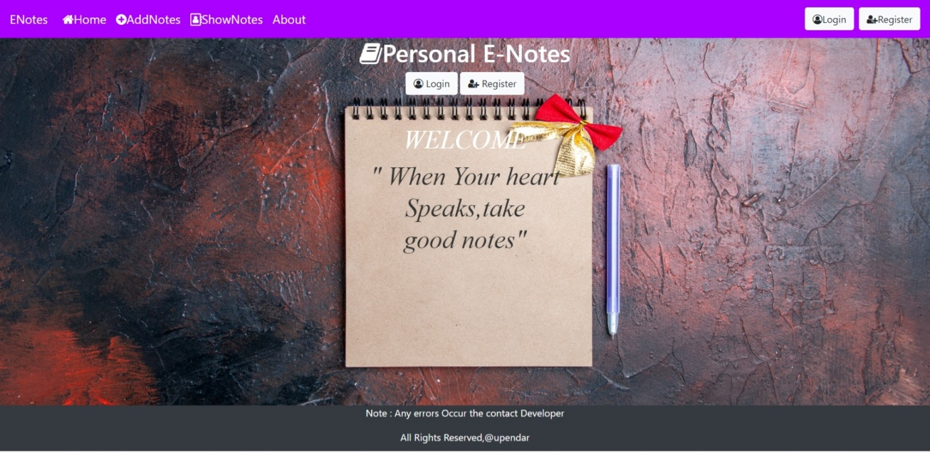

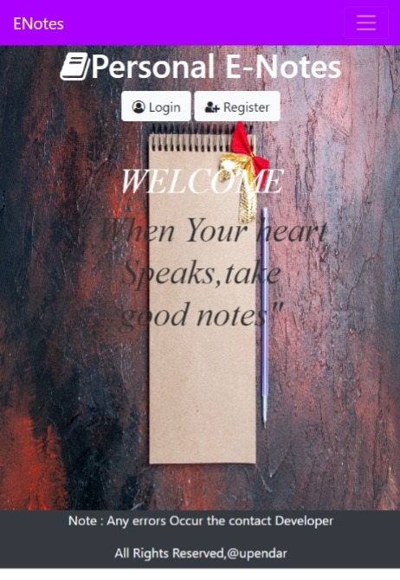

**FIG.1: INDEX PAGE**

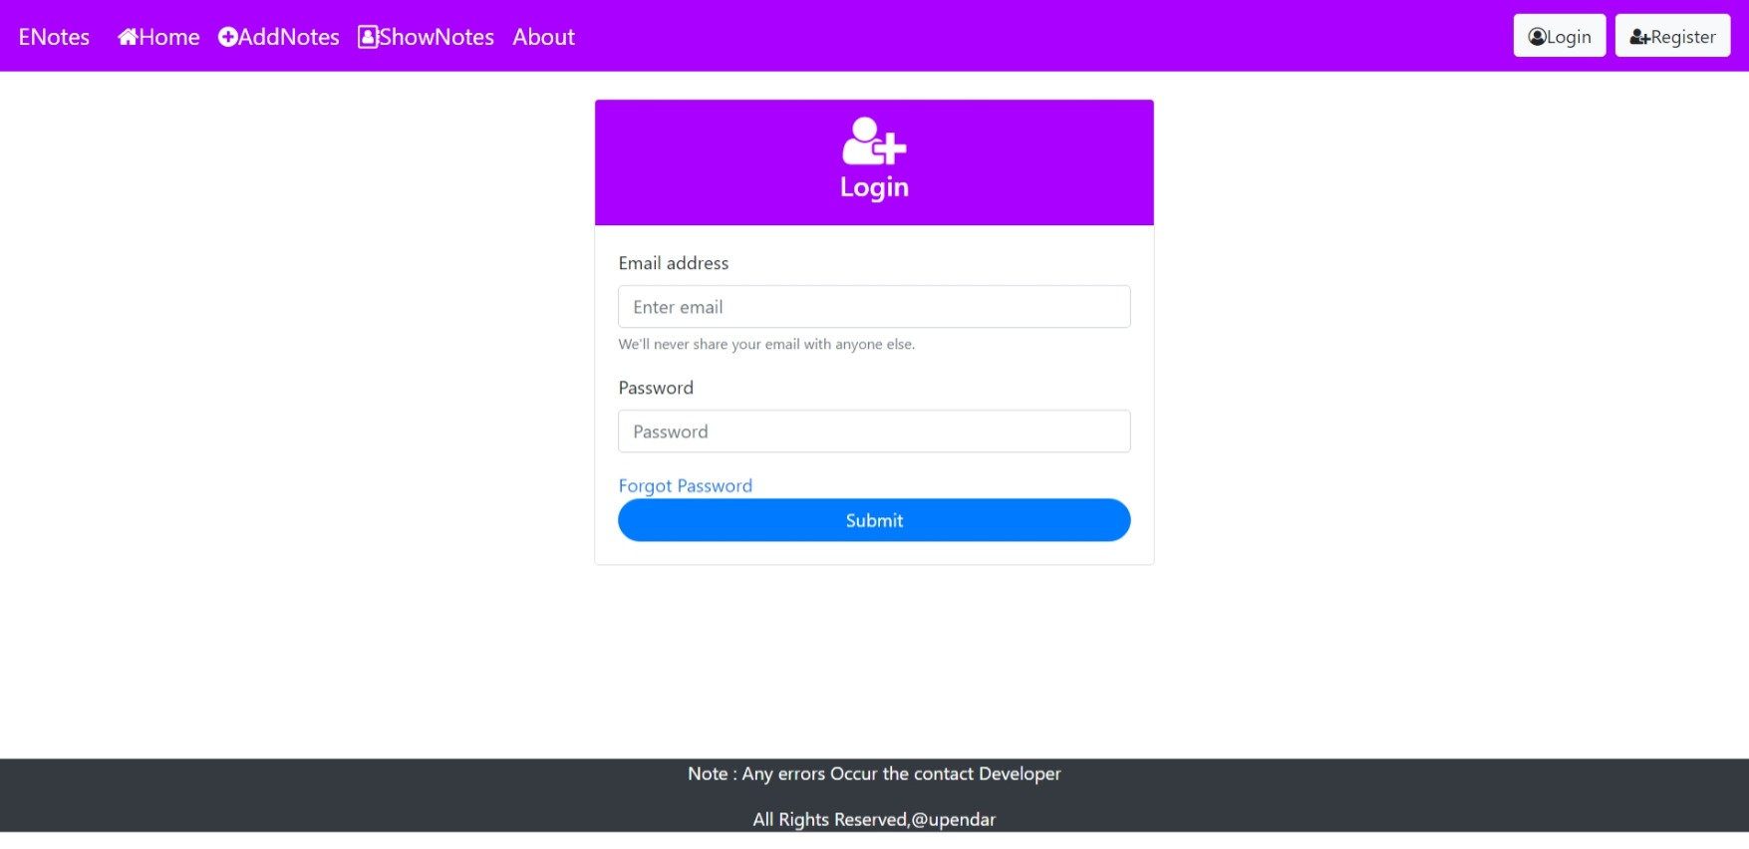

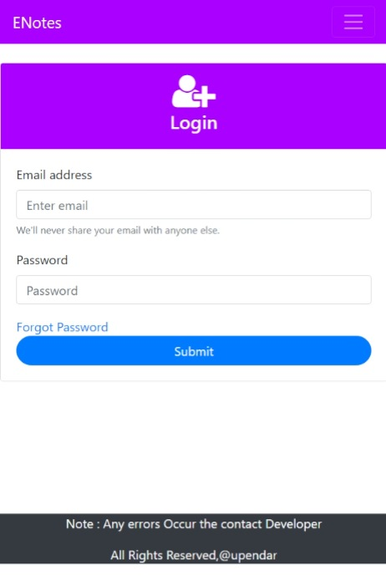**s**

**FIG.2: Login Page**

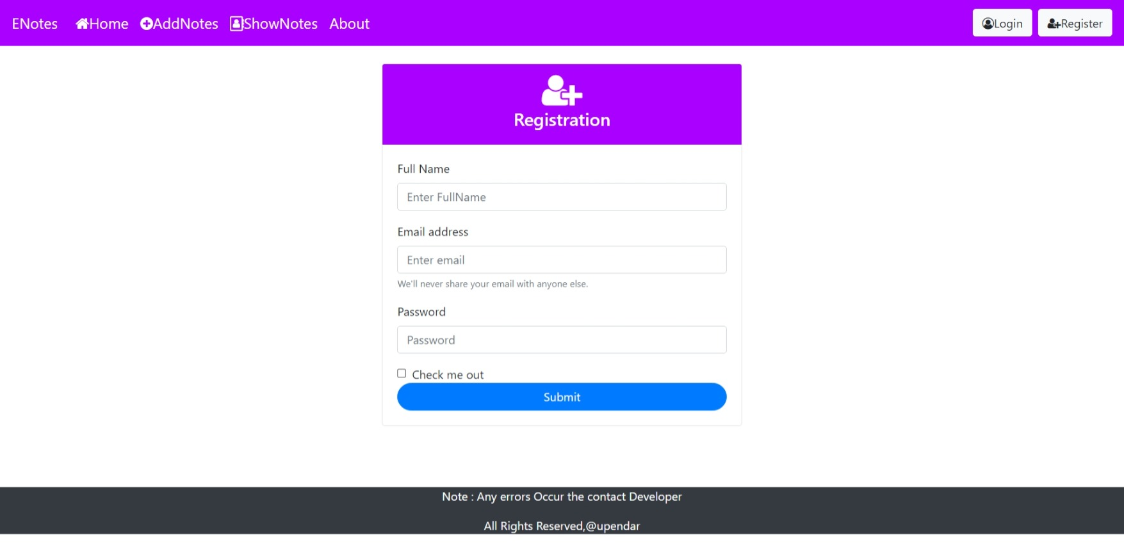

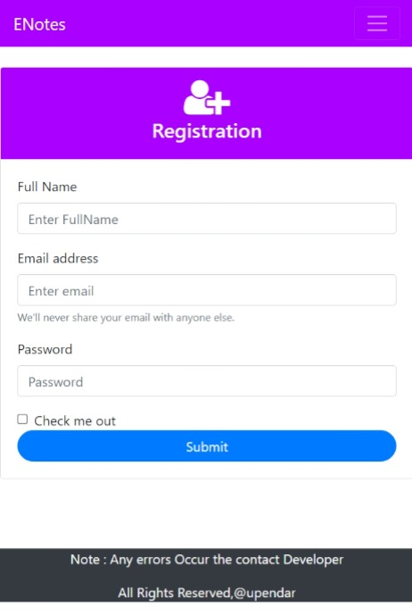

**FIG.3: REGISTRATION PAGE**

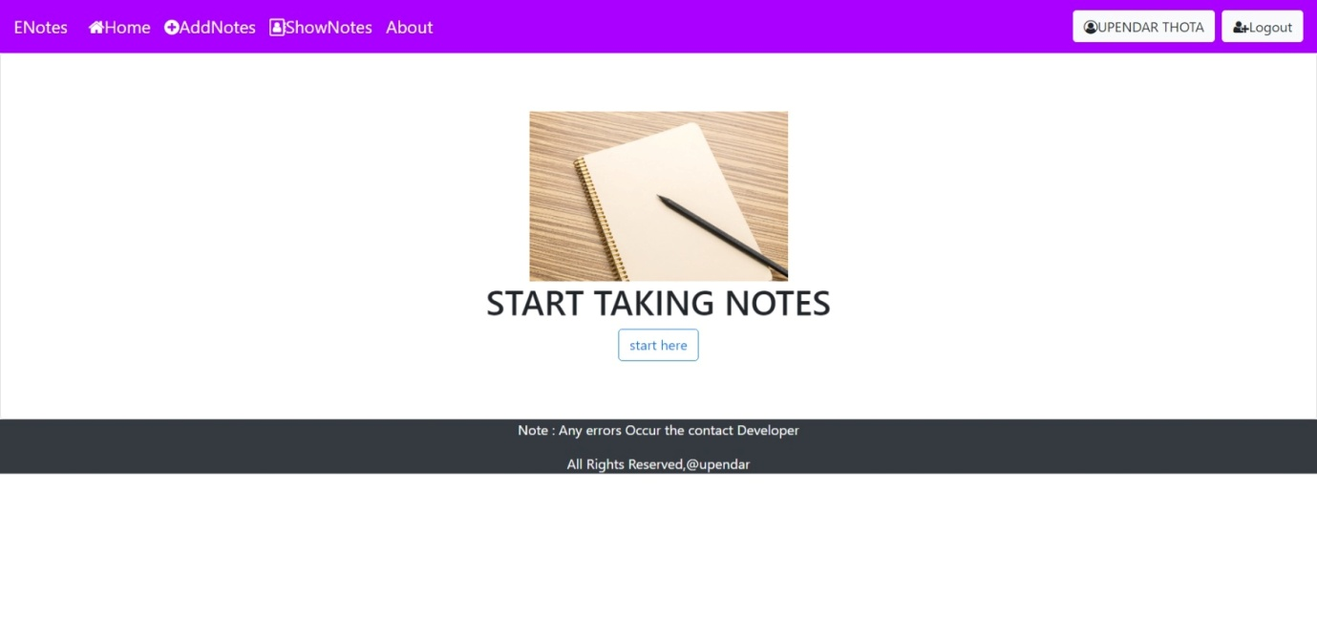

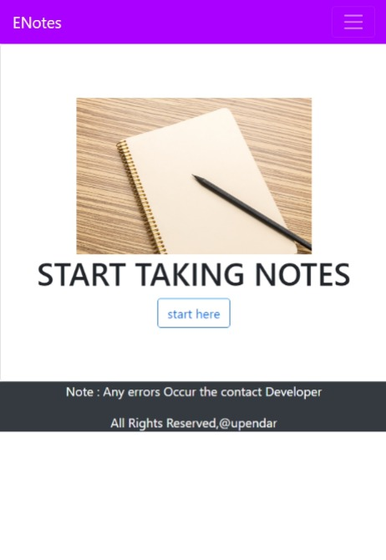

**FIG.4: HOME PAGE**

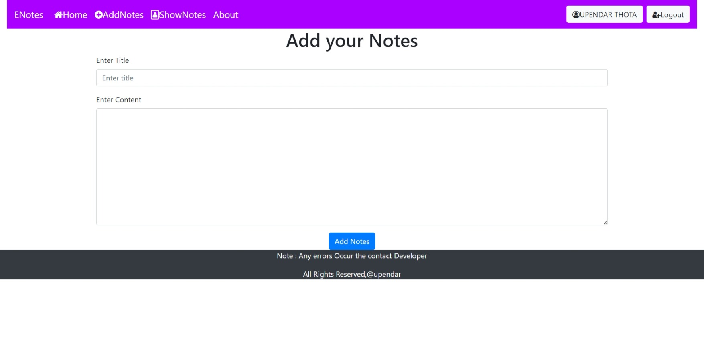

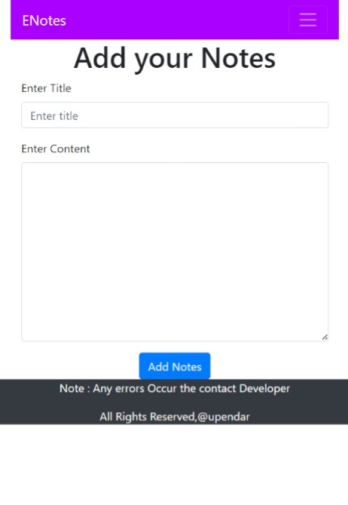

**FIG.5: ADD NOTES PAGE**

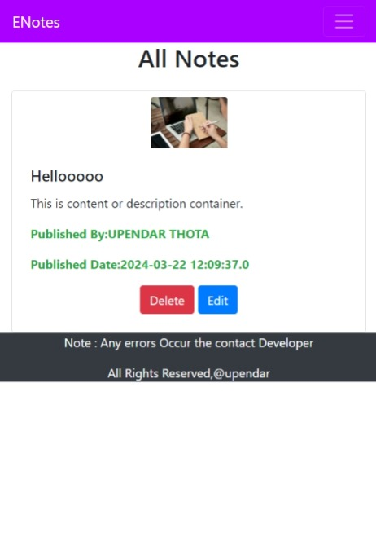

**FIG.6: SHOW NOTES PAGE**

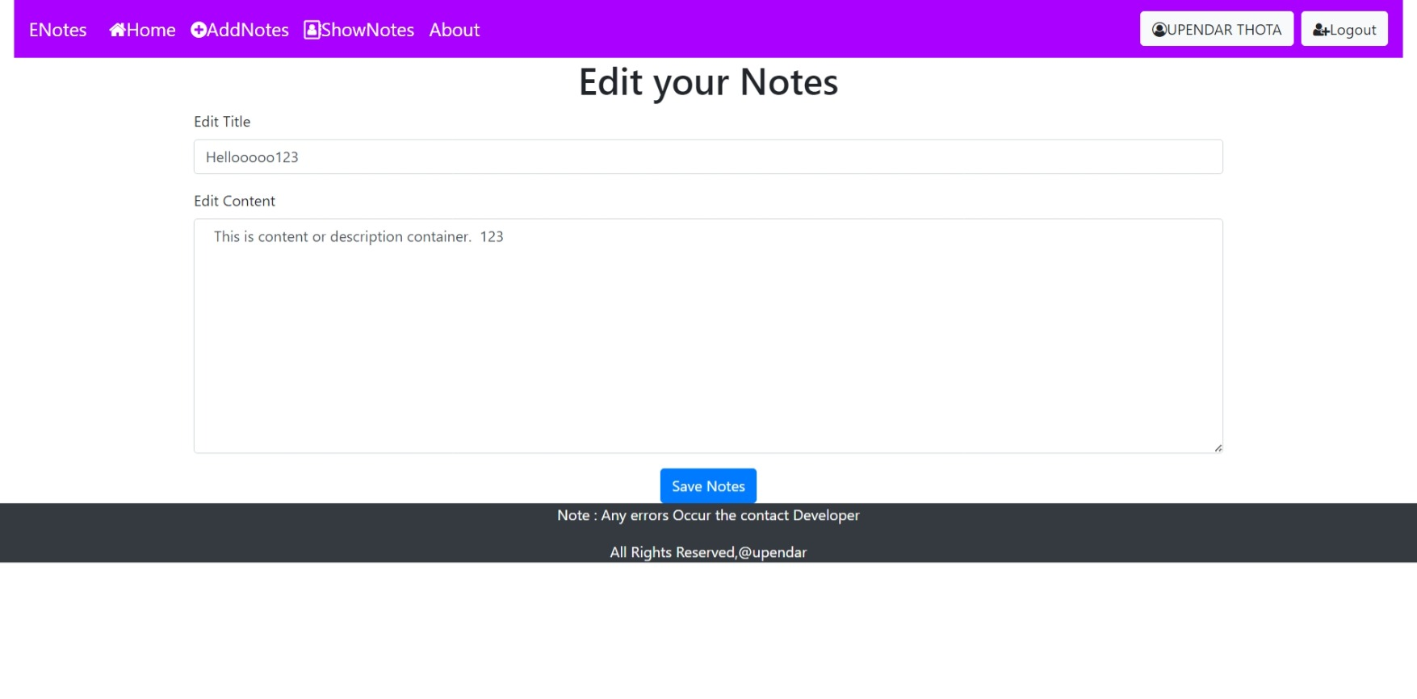

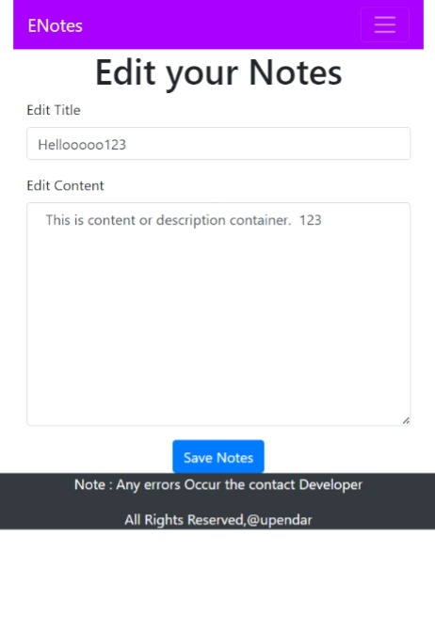

**FIG.7: EDIT PAGE**

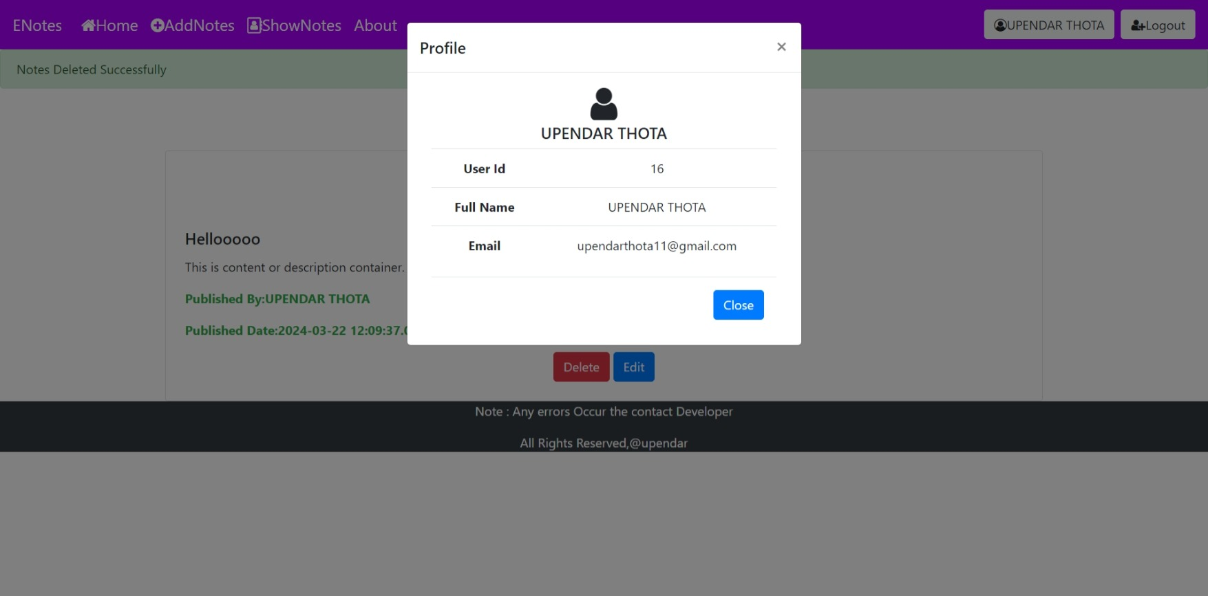

**FIG.8: PROFILE PAGE**

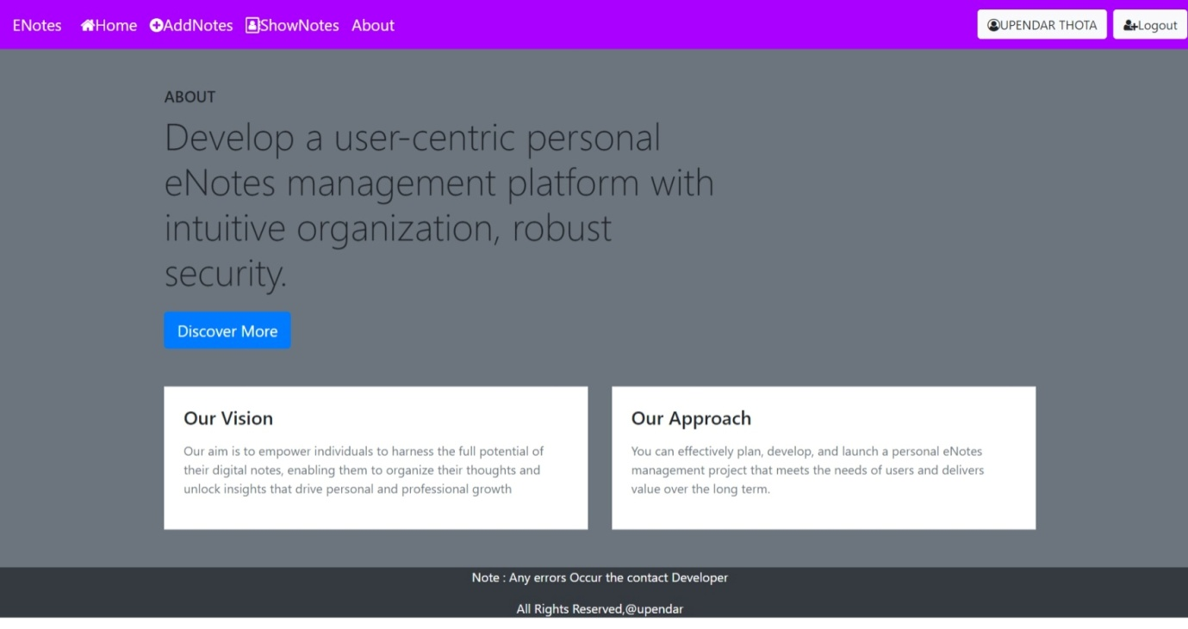

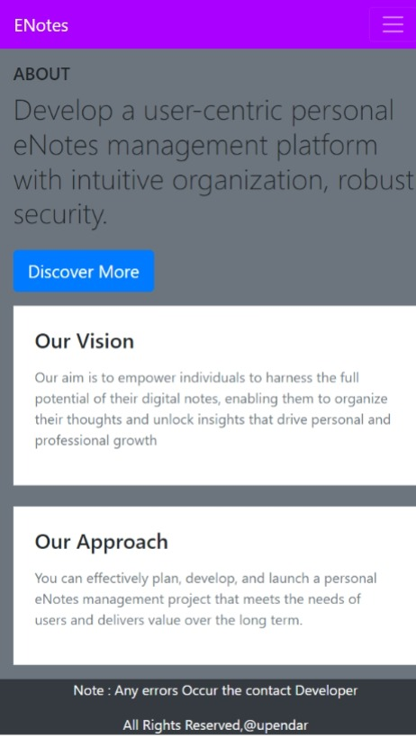

**FIG .9: About page**

**CHAPTER -6**

**CONCLUSION:**

The Personal E-Notes Management Project offers a comprehensive solution to the challenges of personal organization and productivity. Through its user-friendly interface, robust features, and commitment to innovation, it empowers individuals to streamline their note-taking workflows, enhance collaboration, and maximize productivity. With its focus on security, privacy, and sustainability, the project ensures a trustworthy and environmentally responsible platform for users. As it continues to evolve and adapt to emerging technologies and user needs, the project remains poised to revolutionize the way individuals interact with their digital notes and information, driving efficiency and success in their personal and professional lives.

**CHAPTER -7**

**FUTURE SCOPE**

The future scope of the Personal E-Notes Management Project is rich with possibilities for innovation and expansion. With the continuous evolution of technology and the increasing demand for efficient personal organization tools, the project can explore several avenues for growth and enhancement.

One key area for future development is the integration of advanced artificial intelligence (AI) capabilities. By leveraging AI algorithms, the project can offer intelligent features such as natural language processing (NLP) for automated organization and contextual insights, sentiment analysis for understanding users' emotions and priorities, and personalized recommendations based on individual usage patterns.

Moreover, the project can enhance collaboration tools to facilitate seamless teamwork and communication. Real-time co-editing, task assignment, and team chat functionalities can transform the platform into a dynamic collaboration hub for individuals and teams alike.

Additionally, exploring the integration of emerging technologies such as augmented reality (AR) and virtual reality (VR) could provide users with innovative ways to interact with their notes. Imagine being able to visualize notes in a virtual workspace or annotate physical objects with digital notes using AR glasses.

Ensuring the project's accessibility and inclusivity should also be a priority. Features such as screen reader compatibility, multi-language support, and customizable interfaces can cater to users with diverse needs and backgrounds.

Overall, by embracing technological advancements, user feedback, and market trends, the Personal E-Notes Management Project can continue to evolve and thrive, offering users a comprehensive and cutting-edge solution for personal organization and productivity.

**CHAPTER -8**

**REFERENCES**

[**www.w3schools.com**](http://www.w3schools.com)

[**www.javatpoint.com**](http://www.javatpoint.com)

[**www.statckoverflow.com**](http://www.statckoverflow.com)